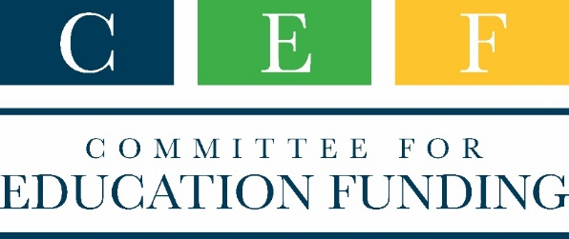
COVID-19 resources regarding mental health and the education community
April 23, 2020

American Counseling Association (ACA) – ACA has a COVID-19 page with sections on :
- Counseling school children, including how to counsel from home, how to talk to children about the pandemic, and self-care for counselors;
- Issues of social isolation, including suicide prevention and how children heal from trauma; and
- FAQs for telebehaviorial health, effective policies, ethics, and licensure

American School Counselor Association (ASCA) – ASCA links to multiple other sources for guidance and resources, along with ASCA toolkits and webinars including:
- Toolkits on crisis planning and response, virtual school counseling guidance for all levels of education, and choosing a college when you cannot visit, and
- Free webinars on ethical considerations of online counseling, how-to for online counseling, and supporting student welfare in an online setting, among others.
National Association of College Admission Counseling (NACAC) – NACAC has a general COVID-19 resource link plus two other tracking tools:
- NACAC’s College Admission Status Update that shows what changes more than 900 colleges have made in their admission processes, and
- NACAC’s Secondary Schools College Admission Services Update that shows what high schools are doing differently to help students with college applications.
National Association of School Psychologists (NASP) – The NASP COVID-19 Resource Center has information for school psychologists and families, including:
- information and links to federal government guidance including from the Department of Education on delivering special education;
- information on assessing mental health crises;
- helping children respond and dealing with racism and stigma; and
- professional preparation and credentialing.

